**Azad Kashmir:**

Leepa Valley

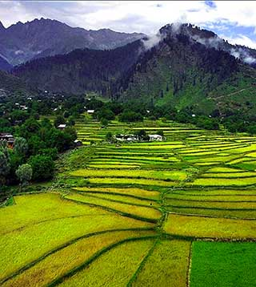

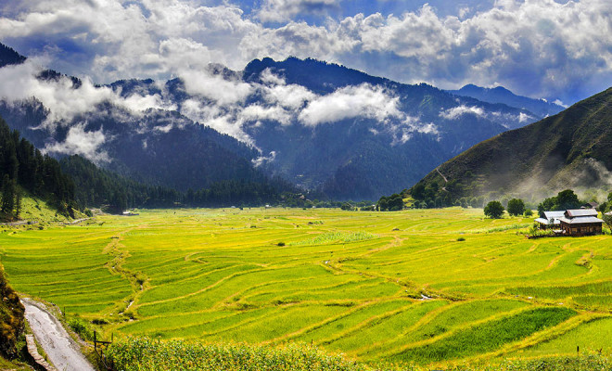

**Leepa Valley** is located in Azad Kashmir, 105 kilometres (65mi) from Muzaffarabad. The valley is divided into the Reshian, Dao Khan, Leepa, and Chananian sections. Leepa Valley was formerly part of Karnah tehsil of Kupwara district in Jammu and Kashmir, India. The valley is now part of Jhelum Valley District in Azad Kashmir, Pakistan. It has been an area of strife among the two neighboring countries.